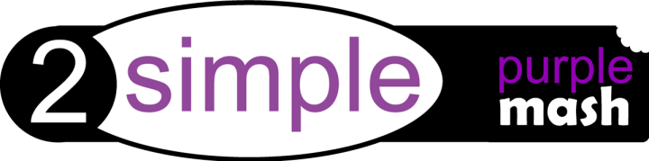

Dear Parent/Carer,

We have recently subscribed to Purple Mash, which is a creative educational website for children. Purple Mash is a cross-curricular resource covering everything from Maths and English to Computing and Art. Your child can access Purple Mash from home on a laptop, desktop or a tablet.
Purple Mash is a safe environment that doesn’t require any downloading or allow interaction with people online and children cannot make any financial transactions.
We will be encouraging the children to further explore the subjects and topics they enjoy from school at home and Purple Mash is a great resource for this. Your child will be taught how to use Purple Mash in school and will be able to use it without supervision but you may want to take a few minutes to explore it yourself so that you can help them with their work.

Creative Tools & Games
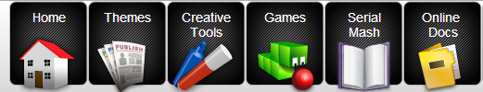
There are 20+ open-ended creative tools and games inside Purple Mash. They range in complexity from simple painting programs to sophisticated coding tools. If you’re using something for the first time it is a good idea to watch the help vidoes which can be found by clicking the monitor icon.

Saving and Sharing Work
Purple Mash lets your child save their work online. It’s very easy just look out for the floppy disk icon on the toolbar and follow the simple instructions. To access saved files go to the ‘Online Docs’ tab. Once saved you can also ‘share’ work. Just look out for the globe icon on the toolbar. This will give you a link that can be used to view the work by people that don’t have Purple Mash.

Topics and Themes
Purple Mash has over 2,000 ready-to-use themed writing and painting projects. They cover everything from aliens to the Victorians. You can either use the ‘Themes’ tab to browse by subject and topic or alternatively use the search bar in the bottom right of the screen to look for something specific.

Want to know more?
If you’re keen to get to know Purple Mash inside and out there is a video trainer that will lead you through the whole of Purple Mash and explain exactly what it can do. You can view the video trainer using the link below.
http://www.purplemash.co.uk/app/videos/videotrainer
2Code
2Code puts children as young as five on the path to becoming computer programmers. Everything is broken down into step-by-step lessons with video instructions. Coding is now a part of the National Curriculum 2014. If you wanted to find out the kinds of things that your children will be learning then having a go at 2Code yourself is a great place to start.
Serial Mash
Serial Mash is all about getting children to read for pleasure. New books are released each half-term as a weekly serial. The chapters come with a range of fun and educational activities. Serial Mash is great for solo or guided reading and can be read on tablets. You can take a look the current books in the ‘Serial Mash’ tab. The books are aimed at children aged 7-9 and 9-11.

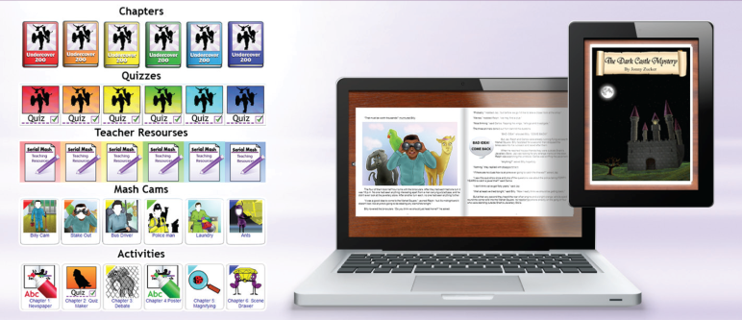
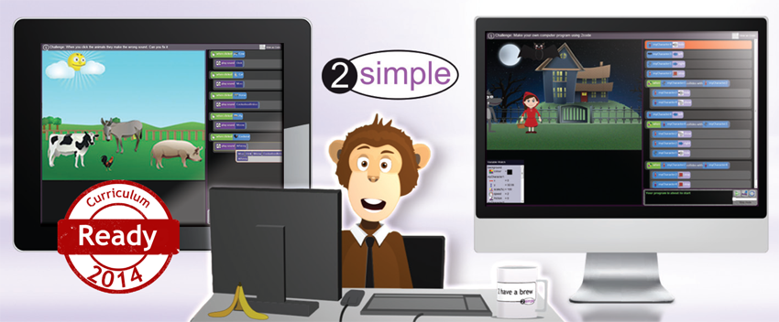

Purple Mash on Tablets

If you have an ipad then there are several free apps that you can download as part of Purple Mash. These include Mash Cams, 2DIY and 2Create a Story. You can download them from the App Store and sign in with your Purple Mash username and password.

Alternatively, you can use Purple Mash on a tablet by opening it up in a browser window on your device. Not all of the tools work on tablets but there are lots that do.

Purple Mash URL
http://www.purplemash.co.uk/..............................................
(You may want to save this as a desktop shortcut)

Username: ............................................................
Password: ............................................................

Please keep this information safe and secure. Do not share your login details. If you cannot login please contact the school directly. For security reasons 2Simple Software cannot give out login details to anyone other than the school administrator – this is for your child’s protection.

